St Edmund’s & St Joseph’s Catholic Primary Schools
Week commencing: 6th April 2020 Year group: 2
Below are some suggestions for learning that your child can do at home this week. We understand that the situation is unprecedented, however we do recommend that the children stay in touch with their learning using the ideas given below. You can help keep your child in contact with the school via the email link shown at the end of this message. Your child may want to share their achievements with their teacher by photographing or scanning it and sending it via email. A teacher will reply with a comment about the work shared.
Please email any completed activities/work to: homelearning@st-edmunds.suffolk.sch.uk

Subject/ Theme | Learning ideas and activities
English | See if you can write a set of instructions for something, Remember To include a list of equipment/ingredients (what you need), a clear method (using numbered steps) and if you can a top tip or helpful hint box.  Try retelling and writing the Easter story – see the attached PowerPoint showing the Easter story. If you have access to a printer there is an ‘Easter flap book’ attached that you could print and complete. | Take a look at the attached ‘Easter cakes’ sheet to see if you follow a set of instructions to bake some Easter cakes. Can you write your own version?  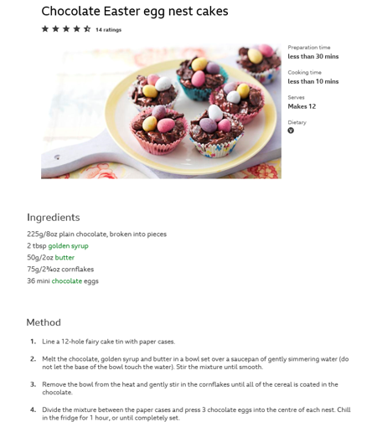
Maths | - Have a go on Timetables Rockstars and/or Mathletics for 15 minutes each day. See if you can improve by the end of the week.  - Recap the 2, 5 and 10 times tables and related division facts.  Shape – See the attached Maths related ‘Easter themed basket craft’ to make your own Easter box. How many edges/faces/vertices (corners) does it have? | 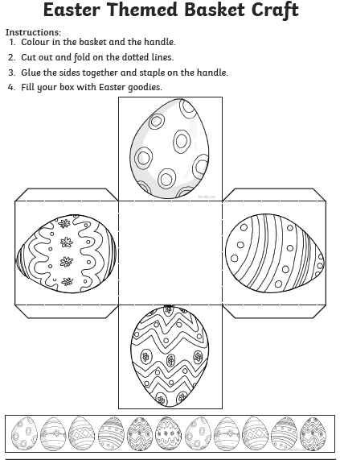
Science, History or Geography
Physical Education | Take part in the 9am live-streamed PE lessons on Youtube with Joe Wicks (Mon to Friday).  Can you complete an Easter related obstacle course or Easter themed quiz in the garden?
Arty crafty ideas | Weaving  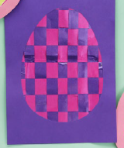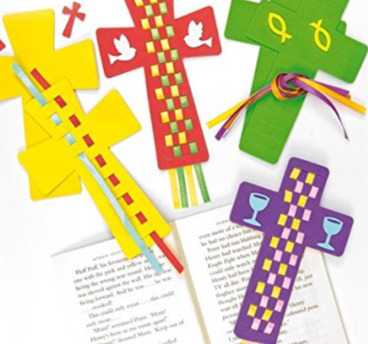 | Take a look at the ‘Woven paper egg craft sheet’ attached. See if you can weave coloured strips of paper to make an Easter egg shape. Remember it’s… over, under, over, under with alternate colours.  You could use ribbon, coloured strips of paper of even use crayons to colour your own pieces. You could even make other Easter themed weaves e.g. crosses

