Monday 6th April 2020
Hello everyone,
I hope you are getting used to spending lots of time at home and you enjoyed a lovely weekend.
The sun shone brightly for us all, which was a real treat. We had our first BBQ of the year. I wonder how many of you did too. We created an obstacle course in the garden for us all to take part in and used a timer to see who was fastest.
Last week we painted more garden pictures and enjoyed making some puppets. My little girl got a sewing machine for her birthday last year but we don’t usually have much time to use it. So, last week we decided to get it out and make some puppets. We planned them first and then made a selection of animal finger puppets. We also made hand puppets and I helped my children to sew by hand (being very careful with the needle of course).
Finally, we decided to finish our week of learning with a puppet show. It was great fun. Maybe you could try making some puppets too and plan your own puppet show as a treat for the people in your house,
I hope you all have a lovely week and the sun will continue to shine for you all. I am extra excited, as I will celebrating my birthday this week, so I think we will be doing lots of birthday related learning in our house!
Take care everyone,
Love from, Mrs Martin
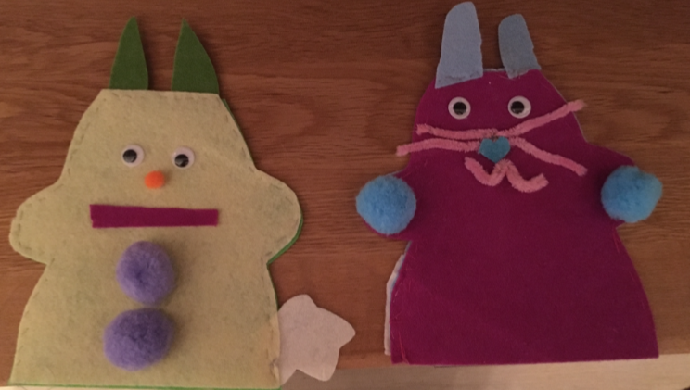
Here are a few photos for you to look at and maybe inspire you at home.
Happy Learning and have a wonderful Easter.


