Friday 3rd April
Hello everyone! I hope you are all well . I have had a lovely two days being in at school this week. I have just arrived home and I am feeling rather tired from all of the Easter and outdoor activities that we have been doing.
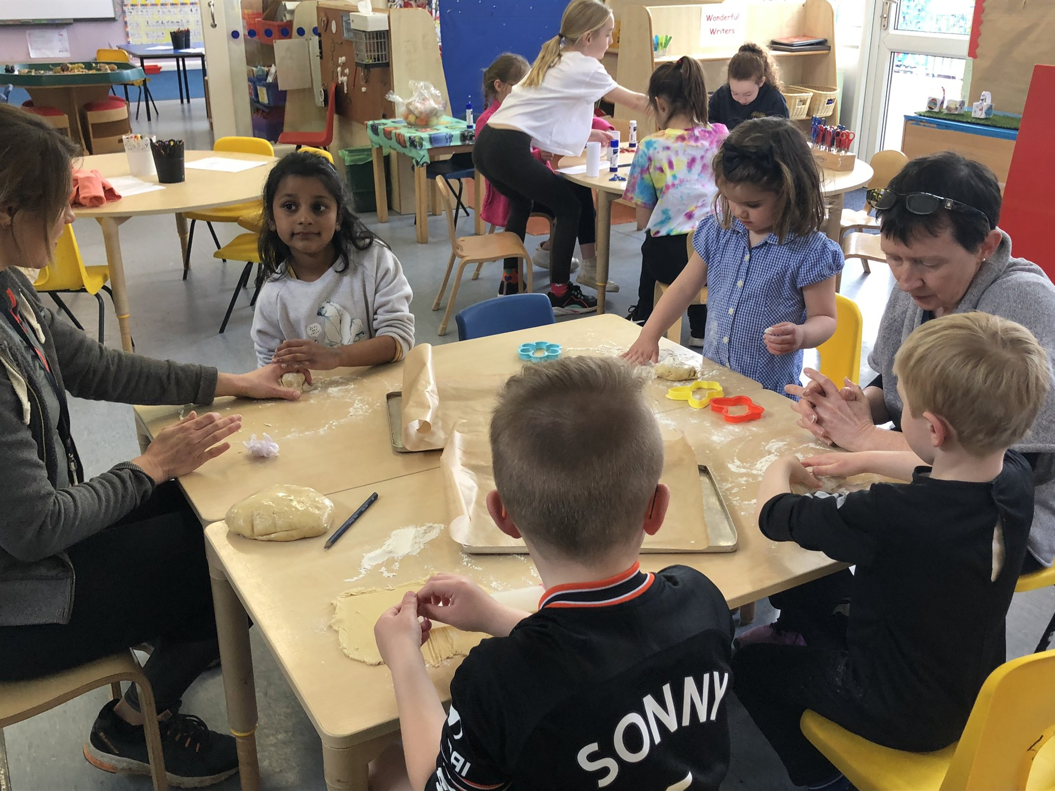
Over the two days, we made Easter baskets and Easter bunnies and then today we made yummy Easter biscuits. We have also made sure that the chickens and the rabbits are clean and fed. They are enjoying all of the space they now have on the field but are missing everyone too.
It is very quiet in school and I missed seeing all of you and the noise you make, especially at lunch times and play times. I hope you have a lovely Easter break and do lots of exciting learning and Easter activities with your families.
Speak soon, Love Miss Bridge x

