Monday 13th April 2020
Happy Easter to you all!
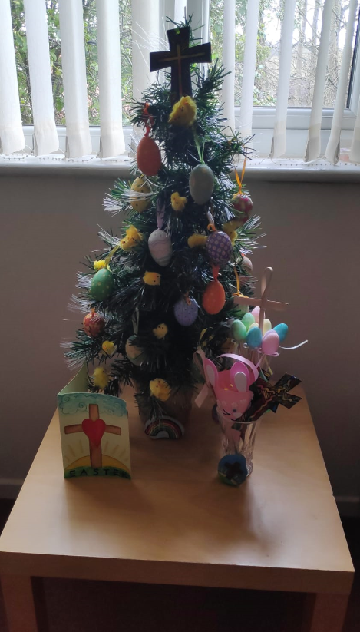
I hope you’ve had a good weekend of celebrations and managed to have a few special Easter treats. I enjoying making some Easter bunting for my lounge and decorated a small Christmas tree with crosses, eggs and chicks. I also painted some pebbles with Easter pictures.
I’ve had lots of fun singing and playing Easter songs. I’ve attached a list with links of some that you might want to sing too. Some of them we have sung at school and church, plus there are a few new ones as well. I look forward to seeing photos and videos of you singing and dancing along to them.
homelearning@st-edmunds.suffolk.sch.uk
I’ve spent extra time outside in my garden this week making the most of the warm, sunny weather. There’s definitely less weeds growing now and it looks a lot tidier. It’s been a treat to be able to eat outside and talk to my neighbours.
My plants are growing taller and stronger. The more sun and water they get, the more they are growing. Hopefully it won’t be long before my flower beds are even more colourful. Have your plants been growing too? I was impressed to see the careful measuring in some of your plant diaries.
I’ve seen lots of rainbow pictures and posters displayed in windows and am very grateful for my specially made one. You might like to see if you can spot any near your house. If you haven’t made one yet maybe you could be creative and make one this week. Some children who have been at school made some and put them in our classroom window so everyone going past St Edmunds can see them They look fantastic!
Have fun and stay safe as you continue your Easter celebrations. Love from Miss Eden 

