Monday 4th May 2020
Hello everyone,
I hope you and your families are keeping well.
I can’t quite believe it is May already and on Friday this week we will be celebrating a very special day - VE day. Celebrations may be a little different to what we had planned but I am sure you will be able to celebrate in your own special way at home with your families. I have attached some VE celebration resources to help you all.
It was a little chillier last week than what we had been used to but I still managed to go for some nice walks with my family. We took a camera with us and took photos of trees, plants and flowers, and used the pictures to create some still life drawings. My children really enjoyed it!
I imagine you are all missing seeing your friends at school. My children are too so we talked about our friends and how special they are to us. I reminded them that I was missing my friends too. We decided to create a friendship flower thinking about all the qualities that make a good friend. My little boy said I could show you all (see the picture below). Maybe you could make one too.
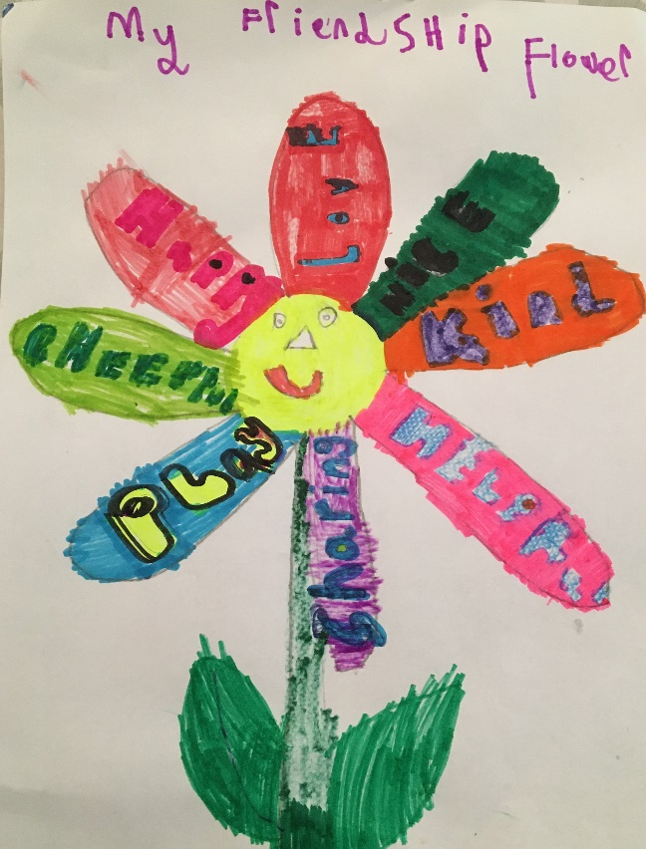

Have a good week and stay safe.
I am missing you all lots.

Love from Mrs Martin x

