St Edmund’s & St Joseph’s Catholic Primary Schools
Week commencing: 11..5.20 Year group: 1
Below are some suggestions for learning that your child can do at home this week. We understand that the situation is unprecedented, however we do recommend that the children stay in touch with their learning using the ideas given below. You can help keep your child in contact with the school via the email link shown at the end of this message. Your child may want to share their achievements with their teacher by photographing or scanning it and sending it via email. A teacher will reply with a comment about the work shared.
Please email any completed activities/work to: homelearning@st-edmunds.suffolk.sch.uk

Subject/ Theme | Learning ideas and activities
English | Read the poems and listen to the audio clips on the poem powerpoint (Weather Sense, The Music of the Wind, A Sense of Weather and The Wild Wind). Have a go at learning one or all of these. As you practice can you use your voice in different ways or use objects around the house to add sound effects? Once you feel confident have a go at performing them for your family. Don’t forget you can record your performances and send them to the home learning email or Twitter – we would love to see them!  Have a go at making up your own weather poem based on ‚A Sense of Weather‘ by Moira Andrew. Use the template to add your own ideas about different types of weather that you like and what you like about them using your senses and then add weather pictures to finish it off. You could perform your own poem too!  Phonics focus for this week:  Spelling shed pattern – wh sound and revision phase 4 cvcc words  Words of the week – sound, feel, taste, look, smell. Can you read and write these independently when you write your poem?
Maths | This week we would like the children to have some further practice and consolidation work on recall of their time tables please  Mathletics has activities set for your child please log on and have a look at what they are. These are really good short maths skills to go over learning that has already taken place this year and consolidate new learning including times tables.  Times table songs are a great way of remembering and learning these!  Have a look at the links below:  https://www.bbc.co.uk/teach/supermovers/times-table-collection/z4vv6v4 (BBC range of Times tables songs available)  https://www.youtube.com/watch?v=3yf3xgE8wMc (Numberjacks 2 x table)  https://www.youtube.com/watch?v=2KyDZ7f1RfE (Numberjacks 5 x table)  Learn ‘drag and drop’ and test yourself on your 2 10 and 5 times tables with this game http://www.learnyourtables.co.uk/en/index2.htm  Quick fire questions on times tables and number bond revision with Hit The Button game https://www.topmarks.co.uk/maths-games/hit-the-button  Times Table Rock Stars – ‘The more we practice the better we get!’  There is also a ‘snakes and ladders’ times tables attachment for you to play with your families this week.  Remember use resources to help you work out the answers if you need to (pasta, buttons toys, drawings of groups)
Science, History or Geography | Geography – Investigate the weather over the next two weeks!  On sunny days look out for shadows and see how you make them change shape – can you get away from your shadow?! Why/why not? Draw round your shadow or make shadow puppets using your hands or paper (see ideas in the week 7 section). Maybe you could have a go at making your own sundial (see sundials document for ideas).  On rainy days get the umbrellas out for a splash or a dance in the rain! Listen to the sounds that the rain makes. Find different ways to collect the rain and measure how much there is. Look at raindrops on leaves, grass, windows and flowers. What do you notice? Transfer a puddle to a container and bring it indoors – watch what happens to it over time! Find things that float in the puddles.  On windy days – go outside and feel the wind on your face. Play with scarves and see how they move in the wind. Tie balloons/flags/scarves to a fence to show how windy it is. Peg some clothes outside on a washing line and watch them move. Make wind chimes using old keys or cutlery on coat hangers and listen to the noises they make!  Use the template to keep a weather diary over two weeks and see how it changes.  Science – Can you complete the dancing raisins challenge? You will need two plastic cups/glasses, water, carbonated water (lemonade) and some raisins. See the attachment with instructions as what to do. We would love to see a video of your dancing raisins! Please send them through to us!  If you want to investigate this further watch this youtube link and have a go with some of these items too!  https://youtu.be/m0LxZXyOOEk
Physical Education | In both schools last week the children have been having a go at Dance with Oti Mabuse. She has a range of different dances you can try including ones to Trolls, Frozen, The Greatest Showman and even Mary Poppins! Type in her name and list of dances are available to choose from.  Or how about some Wildlife Yoga !  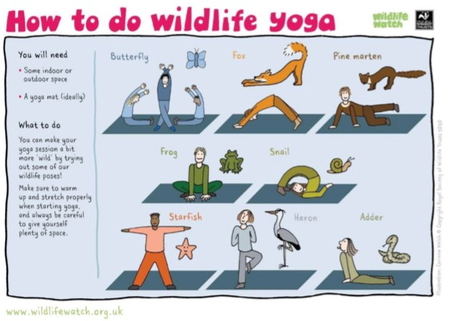
Arty crafty ideas | Art – Look at the powerpoint about Richard Long and the art work that he does. He is an artist who uses a lot of natural objects and makes a lot of circles with them. Talk about what you see, what you like, what you think he has used and what you think happens to the work that he does outside. He uses lots of circles in his work! Have a go at making your own art circles, making the edges of the circle as crisp and accurate as you can. You can use natural materials that you find outside or things that you find around the house. Try to use the same colour and texture if you can, e.g. the same colour sweet wrappers, matchsticks, pasta or paper. They can be as big or as small as you like!  You can also draw different size circles and use pencils or crayons to make different marks in each one. Try flowing, jagged, long, short or zigzagged marks.  Music – Try this song and rap all about the senses!  Follow this link to find the rap  https://www.youtube.com/watch?v=iA1uLc1uEbI Once you have joined in and learnt this rap, maybe you could work with someone in your family to make up your own words for each of the senses.  Look for the ‘Senses song’ in this weeks home learning section and try singing it to the tune of ‘The Farmer’s in the den’.

