St Edmund’s & St Joseph’s Catholic Primary Schools
Week commencing: 8th June 2020 Year group: Early Years
Below are some suggestions for learning that your child can do at home this week. We understand that the situation is unprecedented, however we do recommend that the children stay in touch with their learning using the ideas given below. You can help keep your child in contact with the school via the email link shown at the end of this message. Your child may want to share their achievements with their teacher by photographing or scanning it and sending it via email. A teacher will reply with a comment about the work shared.
Please email any completed activities/work to: homelearning@st-edmunds.suffolk.sch.uk
You can also send us your home learning via Tapestry, we love to see what you have been doing!

Subject/ Theme | Learning ideas and activities
Literacy | 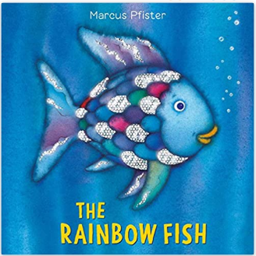  Please enjoy the story of Rainbow Fish (see attached) or you may have your own version to read together.  Draw a picture rainbow fish and write some simple sentences to describe him. Example: The fish is red. The fish is sparkly.
Maths | Draw a fish with six spots, colour 3 spots in your favourite colour. How many spots are left? Choose a different colour for these spots and write a number sentence: 6 – 3 = 3. Repeat with a different number of spots.
Understanding the world (UW) | Use books or the internet to find out two facts about a creature that lives under the sea. Draw your creature and make a fact poster.  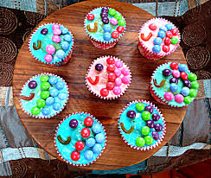  If you have the ingredients can you make some rainbow fish cupcakes?
Physical development (PD) | Can you swim like a fish to the ‘Under The Sea’ music? https://www.youtube.com/watch?v=GC_mV1IpjWA
Art and design ( EAD) | 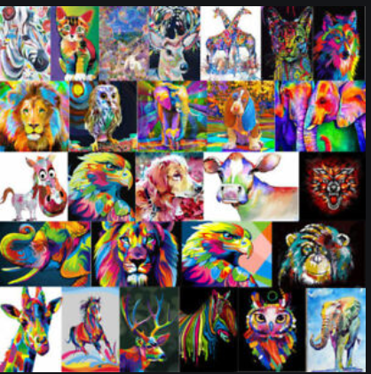  Make a different rainbow animal. You could choose any animal you like and colour it in, paint it or make a collage.  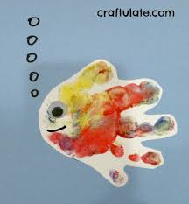  Can you paint a siblings or parents hand in one colour and then the sibling or parents paints the your hand in a different colour then you rub hands together and see which different colours it makes, then make a print of your hands. Then make a rainbow fish by decorating it with gems etc.
Communication and Language (C&L) | 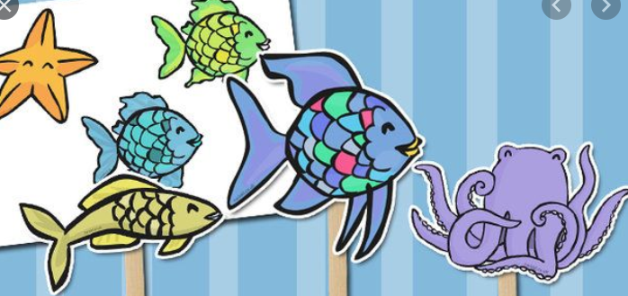  Make some story sticks and retell the Rainbow Fish Story. Video it and send it to us on tapestry.
Personal, Social and Emotional (PSED) | The rainbow fish gave away his most prized possession, his scales. What is your most prized possession? Draw a picture and write a sentence to say why it is so special.
 | Good luck with this weeks home learning, please send photos on Tapestry so we can see how you are getting on and keep up the amazing job you are doing. From all the Early Years Team! We miss you all!

