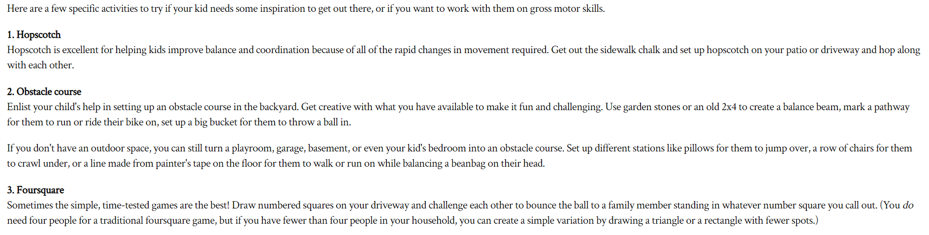
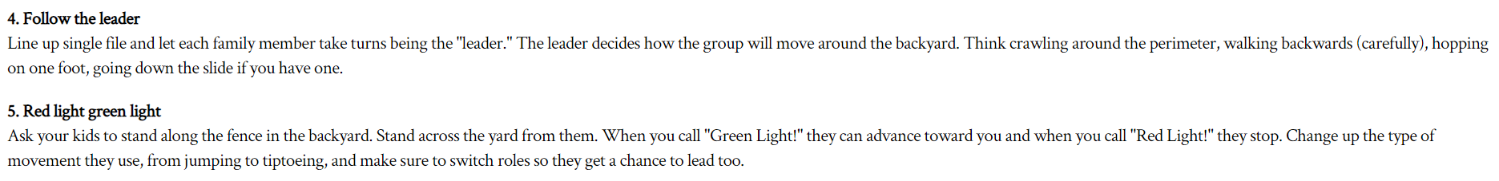
Gross Motor Skills Family Games

