Monkey | banana
ostritch | 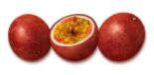guava
zebra 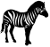 | orange
elephant 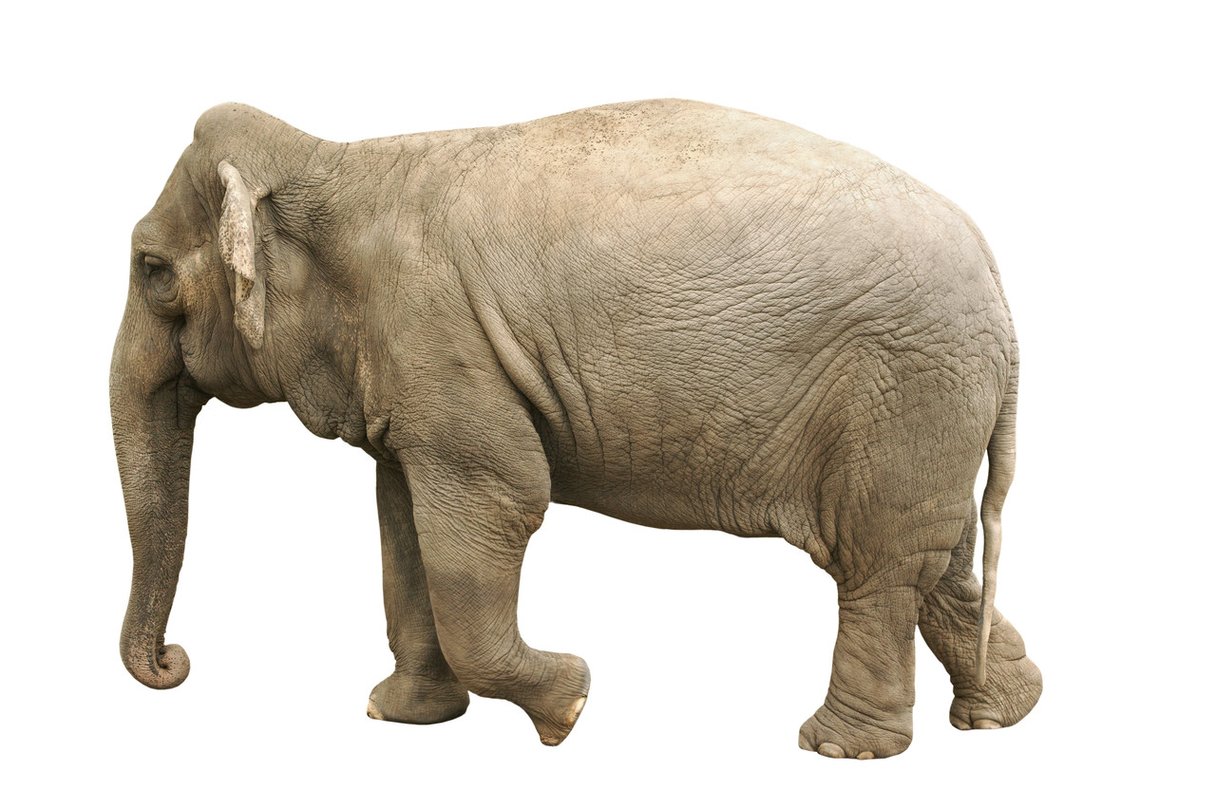 | 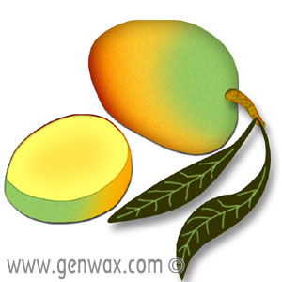mango
giraffe | pineapple
antelope | avocado
parrot | passion fruit 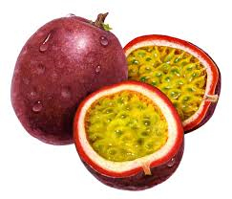
goat | 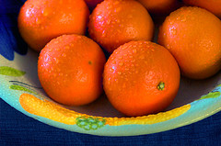tangerines
Cut the animals and fruit out – mix them up on the table and then see if you can pair them up.
Can you put the pairs in order and retell the story to an adult?

