Sunday 7^{h} June
Hello everybody! What a difference there has been in the weather this week although the plants in my garden have been very grateful for the rain and they have been growing fast. Last week I showed you a picture of my cucumber growing and in the space of a week it has grown so much that it was ready to pick which I did this morning. We had it with our lunch and it was delicious!
Lucy gave our dog Luna a bath a couple of days ago and then decided to wrap her in one of her old dressing gowns. She seemed to like it but looked really funny so we took a photo. I thought it might make you chuckle!
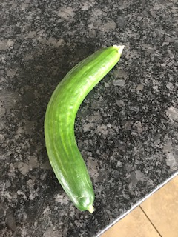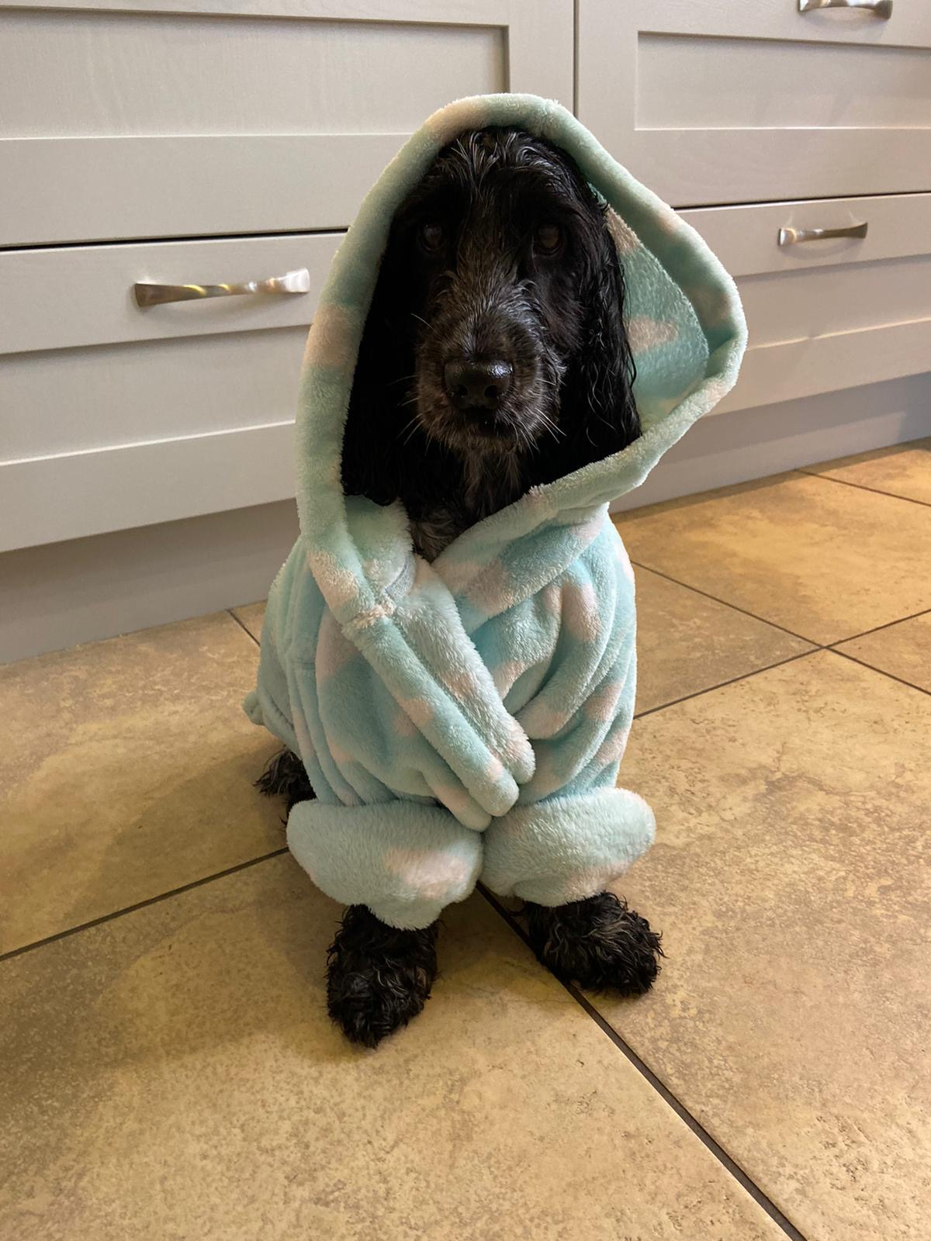
I hope you are staying safe and well.. I’ll write again soon. Take care.
Love from Mrs Mulligan x

