St Edmund’s & St Joseph’s Catholic Primary Schools
Week commencing: 13.7.20 Year group: 1
Below are some suggestions for learning that your child can do at home this week. We understand that the situation is unprecedented, however we do recommend that the children stay in touch with their learning using the ideas given below. You can help keep your child in contact with the school via the email link shown at the end of this message. Your child may want to share their achievements with their teacher by photographing or scanning it and sending it via email. A teacher will reply with a comment about the work shared.
Please email any completed activities/work to: homelearning@st-edmunds.suffolk.sch.uk

Subject/ Theme | Learning ideas and activities
English  RE/PSE  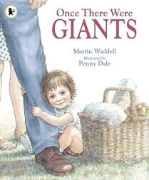  Thrive  Reading  Phonics | A lot of you have been into school to meet Mrs Martin and Mrs McDowell who will be your new teachers at St Edmunds in September.  It would be lovely if you could write a letter to them to bring in with you when you come back to school. You could write about who is in your family, who you like to play with, the kind of activities you like to do at home and what kind of things you like to learn about. We know that your new teachers in year 2 would love to read them.  Read or watch the story Once there were Giants by Martin Waddell.  https://www.youtube.com/watch?v=PM20Kb7hfk0  Talk about your family – who is part of your family? Each family is unique. This means it is one of a kind. Talk about similarities and differences between your family and other families you know. Draw and label a picture of the people in your family.  See if you can look at photos of how you have changed and grown from being a baby to now. Make a list of all the things you can now do independently.  What other family do you belong to? We all belong to God’s family. Can you remember what we talked about in school about being born into God’s family through baptism?  Look at the prayers on the powerpoint and say them together with your family. Maybe you could have a go at writing your own prayer to give thanks for your family. Have a look at the powerpoint to get some ideas from these thank you prayers.  Use the ‘Thrive’ resources for ideas of activities to do with your family.  Scholastic Online Reading- please log on and read a book using your Reading Pro login details sent home via email last half term. Don’t forget to complete your quiz at the end too! Please keep up your reading over the holidays ready for when you come back in September.  The Summer Reading Challenge is still being run by the libraries this year as a digital challenge. Please sign your child up and take part in this over the holidays  https://summerreadingchallemge.org.uk/schools  Please continue to revisit your phase 3-5 phonics using the thrass charts that were sent home at the beginning of lockdown. The phonics play website is still free to use and has many phonics games you can access and play. Link this with your handwriting practise as well.
Maths | Pick your challenge to practise reasoning and problem solving skills using your knowledge of place value.  Challenge 1 – using numbers to 20  Challenge 2 – using numbers to 50  Challenge 3 – using numbers to 100  Join the dots 1-52 to draw the outline of the map of France.  Dont forget to go onto Times Table Rockstars and or Numbots and Mathletics to improve your fluency and knowledge of number bonds and times tables.
Science, History or  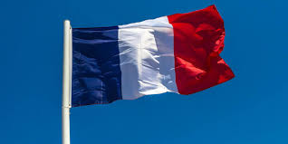  Geography | Geography – Take a trip to Paris in France with Barnaby Bear! See what you can find out about the city. Can you find out how to say hello in French or learn any other new words? What can you learn about the food, weather and animals that live in France? Maybe have a go at drawing or making the French flag. You can visit these sites to help you find information https://www.kids-world-travel-guide.com/france-facts.html https://www.natgeokids.com/uk/discover/geography/countries/facts-about-france/  History – Tuesday 14th July is Bastille Day. What can you find out about why this is celebrated in France? Use these sites to help you research this https://www.ducksters.com/holidays/bastille_day.php  https://www.euroclub-schools.org/bastille-day  You could draw a poster about Bastille Day or draw a picture to show what happened.
Physical Education | Use the French workout instructions to make our own workout!  As this is the final week of the summer term choose one of the many ideas we have suggested this term and maybe try to do something different each day.  Suggestions below:  - GoNoodle  - Zumba  - Cosmic Yoga  - Joe Wickes  - Bike riding / scooting  - Obstacle courses in garden  - Races with your family.  The links and suggestions for all of these have been highlighted in previous weeks learning intentions.
Arty crafty ideas  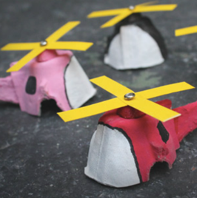  DT challenge  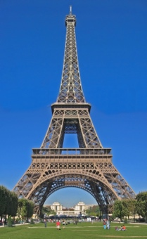 | Junk modelling planes, trains and automobiles! Save your boxes, egg cartons, toilet rolls and bottles and see if you can make a vehicle using them. There are some ideas in the attachments.  Barnaby Bear has been in the kitchen learning how to make French pancakes called crepes. Watch how he gets on here https://www.bbc.co.uk/bitesize/clips/zsbkq6f Maybe you can have a go at making your own! What else might Barnaby Bear eat on a visit to France? Look here to find out about some traditional French foods. https://www.kids-world-travel-guide.com/food-in-france.html  Maybe you could try making and tasting something new - try French stick, Brie cheese, madeleines, saucisson or some Cantaloupe melon.  Learn the French song Frere Jaques and try singing ‘Wind the Bobbin up’ and ‘Head, shoulders, knees and toes’ in French. Use the powerpoint to help learn the words.  You can sing along to Frere Jacques with this link https://www.youtube.com/watch?v=gBbjOyMsUD4 Maybe you can sing it in a round with other people in your family.  Creative ideas to use in the holidays have been put on attachments, many of which are linked to weather. We hope these may be useful as some inspiration to try out during the summer break.  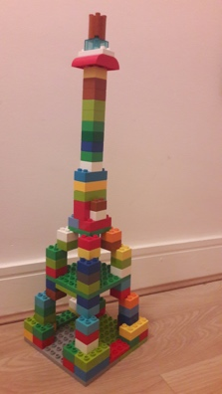  Can you make the Eiffel Tower using lego, straws, marshmallows and spaghetti or cocktail sticks or any other method? Can you make it stand up?

