St Edmund’s & St Joseph’s Catholic Primary Schools
Week commencing: 13th July 2020 Class: Abraham
Learning Characteristic - Collaborative
Below are some suggestions for learning that your child can do at home this week. You can help keep your child in contact with the school via the email link shown at the end of this message. Your child may want to share their achievements with their teacher by photographing or scanning it and sending it via email. A teacher will reply with a comment about the work shared.
Please email any completed activities/work to: homelearning@st-edmunds.suffolk.sch.uk

Welcome to week 16 of Home Learning!! This is also our very last week of term! This week’s Home Learning is going to be a little bit different. As we won’t be able to share sports day together I have given you a sports related challenge for each day.

I would like to say how incredibly proud and impressed at the resilience that has been shown by all our families. The past few months have been a real challenge and it has been heart-warming to see the imaginative and creative activities you have been doing at home. You have all learnt new skills, had a go at tasks you have not tried before and kept up with your spellings, reading and times tables.

I have loved seeing your achievements, reading your stories, watching your videos, looking at some amazing art, admiring delicious baking, watching you do TTRS battles and simply enjoying your time at home.
It has been a real privilege to support you all and I wish you all a happy and relaxing summer break.

Day of the week | Learning ideas and activities
Monday  Warm up  5 press ups  10 star jumps  5 sit ups | Balance game  Use anything large or small and experiment balancing it on any part of your body. Using harder and more obscure objects to balance on yourself. Easy? Try and balance multiple objects on someone else. Human Buckaroo!
Tuesday  BASTILLE DAY  Warm up  8 press ups  10 star jumps  8 sit ups | July 14th marks the French National Day, a day when French people celebrate being French! It is a bank holiday in France and there are military parades, fireworks and street parties to remember the importance of being united as a country.  Go to the PDF document on your class's home learning page, and match up each symbol to its description. (Use the picture on the second page to help you). Have a go at the extension activity too, it could be a lot of fun! (Madame Wallace’s personal favourite includes using toothpicks and mini-marshmallows to make the Tour Eiffel!)
Wednesday  Warm up  8 press ups  15 star jumps  8 sit ups | Trivia game  Using post it notes write a sport on a sticky and stick it on your partners forehead without them seeing. You must now act out that sport and they have to try and guess the sport you are acting. REMEMBER - you are not allowed to talk!
Thursday  Warm up  10 press ups  15 star jumps  10 sit ups | Word search  See the attached sports themed word search.
Friday  Warm up  12 press ups  18 star jumps  12 sit ups | Juggling  Using three soft similar size objects. Start with two and practice until you can introduce a third. Challenge: Use another person and juggle as a pair.
Transition Activities

Usually, at this time of year, we have a transition morning where the children get to meet their new teachers and the teachers learn some facts about their new class. As we unable to do this we have set 2 activities to be done over the summer and to be brought into school on the first day back.

Activity 1
Can you draw around your hand and decorate it as neatly and beautifully as you can. Make it bold and bright!! (Please put your name on the back).

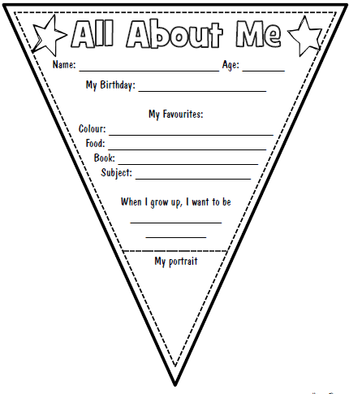
Activity 2
Your new teacher would like to know a bit more about you. You can print off the piece of bunting to complete or draw your own, but you need to answer the same questions.

