St Edmund’s & St Joseph’s Catholic Primary Schools
Week commencing: 13-07-2020 Year group: 5
Below are some suggestions for learning that your child can do at home this week. We understand that the situation is unprecedented, however we do recommend that the children stay in touch with their learning using the ideas given below. You can help keep your child in contact with the school via the email link shown at the end of this message. Your child may want to share their achievements with their teacher by photographing or scanning it and sending it via email. A teacher will reply with a comment about the work shared.
Our Assembly will be on Wednesday this week.
We’ll try and run the assembly for about 10-15 minutes, if you could mute your microphone and use the chat instead then we won’t all be talking over each other!
When you join the Google Meeting, please can we request that you either have your camera on, or if you do not wish to use the camera, please ensure that the alias is recognisable or use a photograph so that we know who you are and can admit you to the meeting – Thank You.
We will send the Google Meet code through e-mail so stay tuned!
Please email any completed activities/work to: homelearning@st-edmunds.suffolk.sch.uk

Subject/ Theme | Learning ideas and activities
English | Keep reading and completing those Accelerated Reader Quizzes -  https://ukhosted100.renlearn.co.uk/2066971/  English – Poetry – Listen to and Enjoy a variety of Poetry.  The Jabberwocky - https://www.youtube.com/watch?v=iBFSiGDZC-Y  Attacked by a Banana - https://www.youtube.com/watch?v=v36XiaAnqiA  Then have a go at creating your own Poem, it could be a rhyming Poem (using a rhyming structure) or an Acrostic Poem, where you write a word (vertically) then use the letters to create a poem (such as the one below)  BBC Bitesize Daily Lessons - https://www.bbc.co.uk/bitesize/tags/zhgppg8/year-5-lessons/1  Write a simple story that you could make into a picture book, can you add some illustrations?
Maths | BBC Bitesize Daily Maths Lessons  https://www.bbc.co.uk/bitesize/dailylessons  Daily Maths Lessons from White Rose Maths Hub (Summer Week 6)  Click here to access the White Rose Maths Hub Resources  Metric Units  Imperial Units  Converting units of time  Timetables  Timestable Rockstars - Keep up with the session challenges – this week to complete 5 studio, 5 garage, 2 sound check and 2 festival activities.  There is also a weekly battle of the bands between 5D and 5P – Who is going to win this week?  Mathletics Activities  What time will it be?  Time Mentals  Test
Science, History or Geography | Geography – Maps  https://www.bbc.co.uk/bitesize/topics/zvsfr82/articles/zdk46v4  Remind yourself on how to read a map, especially OS Maps.  Can you find the following places on the map? The School, The Abbey Gardens, West Suffolk Hospital, The Town Centre, Your House (If it’s in town.  (Use the link to make it easier)  https://www.walkingclub.org.uk/maps/os/explorer/211-bury-st-edmunds-stowmarket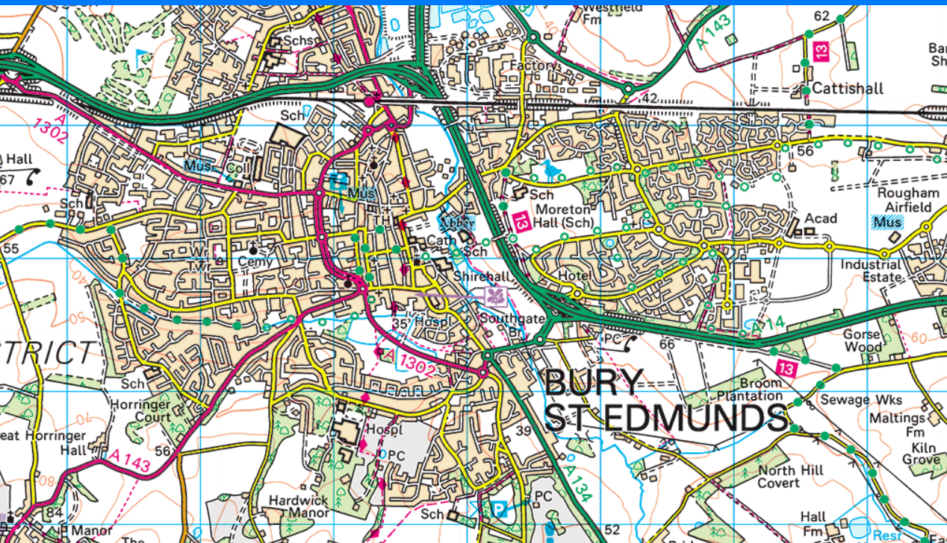
Physical Education | Daily PE Lessons with Joe Wicks  Koo Koo Ranga Roo - https://www.youtube.com/user/kookookangaroo  Park Run Daily Challenges  Description: Each morning a new challenge for the day is posted on the Park Run YouTube channel. All challenges can be done around the house or in the garden. Every Sunday morning there is a special junior parkrun warm-up that the whole family can try in the living room or garden!
PSHE / THRIVE | Choose an activity from this week’s THRIVE sheet – from the attachment in this folder.  Being the last week of the school year, reflect upon the past year – what has been our best memory? What has been challenging? What have you got better at? What are you looking forward to next year?
RE | Read through the Aspire Activities in this week’s folder.  Create an end of term prayer – it could give thanks for experiences in the past year, looking forward to the Summer Holidays and looking further forward to the new year, with new classes, new teachers and new experiences.
Music | Summer Music – What is your favourite summery song / piece of music? Why have you chosen it? How does it make you feel?  If you were asked to design the cover (artwork) - they used to be used on vinyl records and tapes (ask your parents!) and CDs. - what would that cover look like?
Arty crafty ideas | Still Life Art – Use Pencils or charcoal to create sketches. Experiment using depth and perspective to create a 3D picture.  https://www.bbc.co.uk/bitesize/topics/ztjqtfr/resources/1  In school, some children are going to attempt to write and illustrate a picture book, using their own ideas and some of the techniques they have practised from Drawing with Rob.
French | FRENCH NATIONAL SYMBOLS.  July 14th marks the French National Day, a day when French people celebrate being French! It is a bank holiday in France and there are military parades, fireworks and street parties to remember the importance of being united as a country.  Go to the PDF document on your class's home learning page, and match up each symbol to its description.( Use the picture on the second page to help you). Have a go at the extension activity too, it could be a lot of fun! (My personal favourite includes using toothpicks and mini-marshmallows to make the Tour Eiffel!)
Classroom Secrets Resources: https://classroomsecrets.co.uk/free-home-learning-packs/
Classroom Secrets are producing a set of weekly learning packs that link to some of the Maths and English activities - each week being subsequently split into the appropriate daily teaching slots.
Children currently in school will be accessing these resources, so if your child is in school full time or just for specific days please don't make use of these resources at home ahead of the specified day so that your child isn't repeating an activity when they're in school.
Thank you.

