St Edmund’s & St Joseph’s Catholic Primary Schools
Week commencing: 13th July 2020 Year Group: Solomon
Below are some suggestions for learning that your child can do at home this week. We understand that the situation is unprecedented, however we do recommend that the children stay in touch with their learning using the ideas given below. You can help keep your child in contact with the school via the email link shown at the end of this message. Your child may want to share their achievements with their teacher by photographing or scanning it and sending it via email. A teacher will reply with a comment about the work shared.
Please email any completed activities/work to: homelearning@st-edmunds.suffolk.sch.uk

Subject/ Theme | Learning ideas and activities
English | Reading: Please ensure that you are reading for at least 30 minutes every day and completing the quizzes using the link following link: https://ukhosted100.renlearn.co.uk/2248266 , or  Choose a story from this link (free stories)  Writing:  Work through the daily lesson on the BBC Bitesize site  Spelling: practise the weekly words on spelling shed
Maths | Warm up with some daily Magic 10  Work through the questions on The White Rose site (the worksheets can’t be accessed but the children can still answer questions on paper as they view the video)  Or  You can work through the daily lesson that is provided each day on the bbc bitesize: LINK  Work through the tasks on Mathletics  Continue to practise on TTRS  Want to try an extra challenge:  https://classroom.thenational.academy/year-groups/  Matchstick maths puzzles:  https://www.funwithpuzzles.com/2017/04/matchstick-puzzles-for-kids-with-answers.html  Games and interactives:  https://nrich.maths.org/9086
Science/Sport/Cooking | BBC Bitesize Daily Year 5 lessons:  Monday: Science challenge ‘Spectacular Space’  Tuesday: Sport UK coaching  Thursday: Dance and Music ‘Alice in Wonderland’  Friday: Cooking pancakes
Religious Education | Below is a link to the CAFOD website where you can access education resources and be thoughtful. Have a look at the children’s prayers section or explore the resource pack of the week.  https://cafod.org.uk/Education/Primary-teaching-resources/Home-learning-primary
Physical Education | Try some of the LTA Youth Home Tennis training activities  https://www.lta.org.uk/tennis-at-home or  Try the ‘Go Noodle’ workouts  Zumba
French | July 14th marks the French National Day, a day when French people celebrate being French! It is a bank holiday in France and there are military parades, fireworks and street parties to remember the importance of being united as a country.  Go to the PDF document on your class's home learning page, and match up each symbol to its description.( Use the picture on the second page to help you). Have a go at the extension activity too, it could be a lot of fun! (My personal favourite includes using toothpicks and mini-marshmallows to make the Tour Eiffel!)
Transition | Usually, at this time of year, we have a transition morning where the children get to meet their new teachers and the teachers learn some facts about their new class. As we unable to do this we have set 2 activities to be done over the summer and to be brought into school on the first day back.  Activity 1  Can you draw around your hand and decorate it as neatly and beautifully as you can. Make it bold and bright!! (Please put your name on the back).  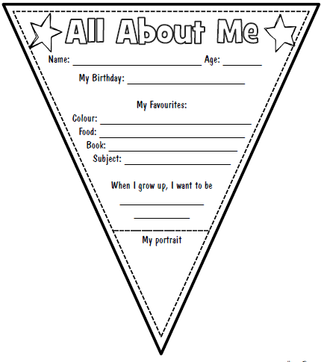  Activity 2  Your new teacher would like to know a bit more about you. You can print off the piece of bunting to complete or draw your own, but you need to answer the same questions.
Art | Create your own ‘Street Art’ using the Tate modern website  https://www.tate.org.uk/kids/games-quizzes/street-art

