Monday 18th May 2020
Hello everyone,
I hope you have had a good week and are continuing to enjoy your home learning.
In the Martin house, we have been busy getting ready for my little boy’s birthday. He will be three on Friday and is getting excited counting down the sleeps. My other two children have been busy making him some books based on the ‘That’s not my.. .’ series. He has a couple of books already that he loves and is beginning to pick them up and try to read all by himself (sometimes holding the book the wrong way round!)
Here is a picture so you can see what they look like. We just need to add all of the different materials to the pictures to make them feely books.
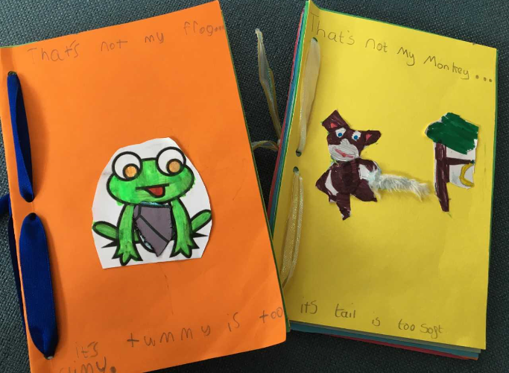
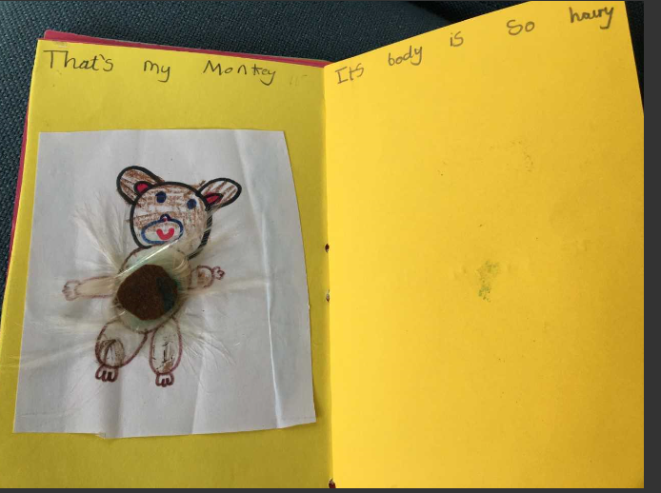
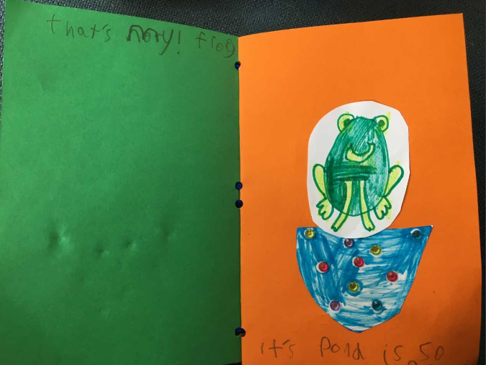
We have a mini keyboard at home so we are going to try and learn to play ‘happy birthday’ so we can have music while we sing happy birthday to him. He loves Paw Patrol too so we are going to try to make him a Paw Patrol cake.
If you or anyone in your family have a birthday soon I hope you all have a lovely time and enjoy spending time together.
Take care everybody. Missing you all lots. Love from Mrs Martin

