Sunday 30h May

Hello everyone. I hope you have had a lovely half term and are enjoying the sunshine. It has been such lovely weather although the plants in my garden have been very thirsty so I’ve had to make sure I keep them watered. Our first cucumber is growing fast – I think we might be able to harvest it in the next couple of weeks. As I was in the garden a few days ago, I spotted a moth resting on a plant. Lucy and I did some research and found out that it is called a Buff Tip Moth. It was amazing as it looked just like a twig from a silver birch tree!

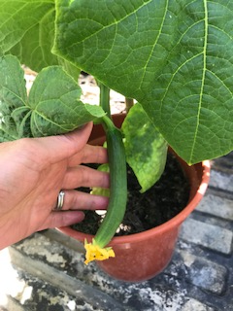 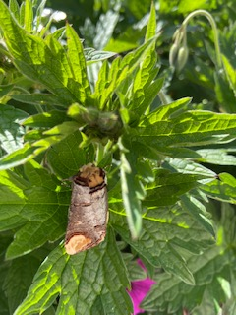

I hope you are all well. I’ll write again soon. Take care.

Love from Mrs Mulligan x