Transition Activities – Summer 2020

Mr Francis is very exited to meet his new class and welcome you to 4F! He would like you to do these 2 activities over the summer so we can get to know some facts about you!
Usually, at this time of year, we have a transition morning where the children get to meet their new teachers and the teachers learn some facts about their new class. As we unable to do this we have set 2 activities to be done over the summer and to be brought into school on the first day back in September.

Activity 1
Can you put three things in a shoebox that let Mr Francis know something about you, it could be a photo of your pet, your favourite toy or book. Bring the shoebox in in the first week of term and you will be looking through them together in the first couple of weeks.

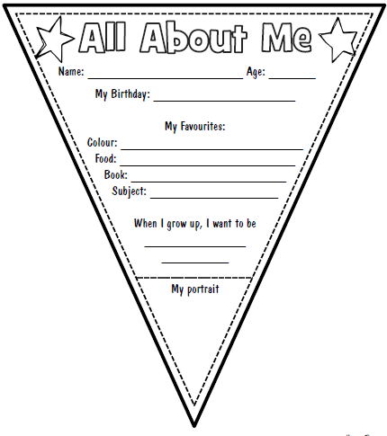
Activity 2
We would like to know a bit more about you. You can print off the piece of bunting to complete (see on Year 3 Home Learning page) or draw your own but answering the same questions.

