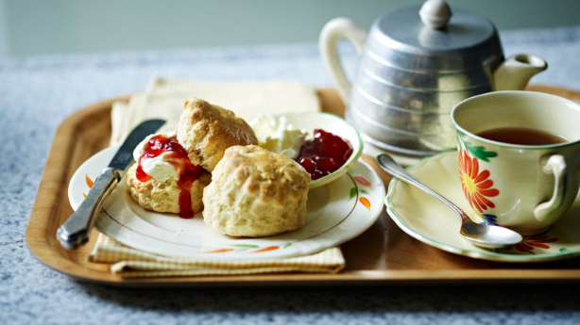
Mary Berry Scone’s (BBC recipe)

Ingredients
- 450g/1lb self-raising flour
- 2 level tsp baking powder
- 50g/1¾oz caster sugar
- 100g/3½oz butter, softened, cut into pieces
- 2 free-range eggs
- a little milk
- handful sultanas (optional)

Method
- Preheat the oven to 220C/200C Fan/Gas 7. Lightly grease two baking trays.
- Put the flour, baking powder and sugar in a large bowl. Add the butter and rub in with your fingertips until the mixture resembles fine breadcrumbs.
- Crack the eggs into a measuring jug, then add enough milk to make the total liquid 300ml/10fl oz. Stir the egg and milk into the flour – you may not need it all – and mix to a soft, sticky dough.
- Turn out onto a lightly floured work surface, knead lightly and work in the sultanas, if using. Roll out to a rectangle about 2cm/¾in thick.
- Cut into as many rounds as possible with a fluted 5cm/2in cutter and place them on the prepared baking trays. Brush the tops of the scones with a little extra milk, or any egg and milk left in the jug.
- Bake for 12–15 minutes, or until the scones are well risen and a pale, golden-brown colour. Lift onto a wire rack to cool. Eat as fresh as possible.
- To serve, split the scones and serve with strawberry jam on the plain scones along with a good dollop of clotted cream.

Recipe Tips
Once the scones are cool, they can be frozen. To eat, defrost at room temperature and then reheat in a hot oven for 10 minutes. The scone dough should be slightly sticky to give the best results.
Don’t over handle the dough or it will be tough and don’t be tempted to roll it out too thinly or you won’t get good deep scones.
For larger 5cm/2in scones, bake for 10-12 minutes

