Transition activities

Usually, at this time of year, we have a transition morning where the children get to meet their new teachers and the teachers learn some facts about their new class. As we unable to do this we have set 2 activities to be done over the summer and to be brought into school on the first day back.

Activity 1
Can you draw around your hand and decorate it as neatly and beautifully as you can. Make it bold and bright!! (Please put your name on the back).
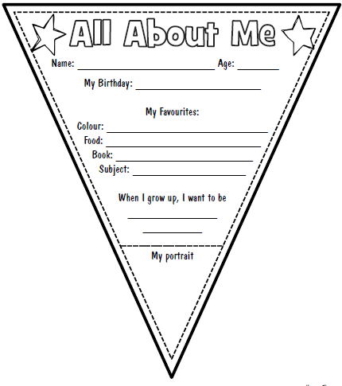
Activity 2
Your new teacher would like to know a bit more about you. You can print off the piece of bunting to complete or draw your own, but you need to answer the same questions.

