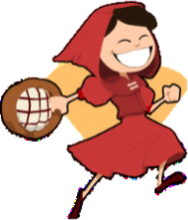
L.O. To read and discuss and narrative poem
Task 2

Have fun with making some similes for a character in one of the Revolting Rhymes.
As

as

_____________________ like

_____________________ like

As

as

__________________________ like

As

as
As

as
As

as
As

as
Character

