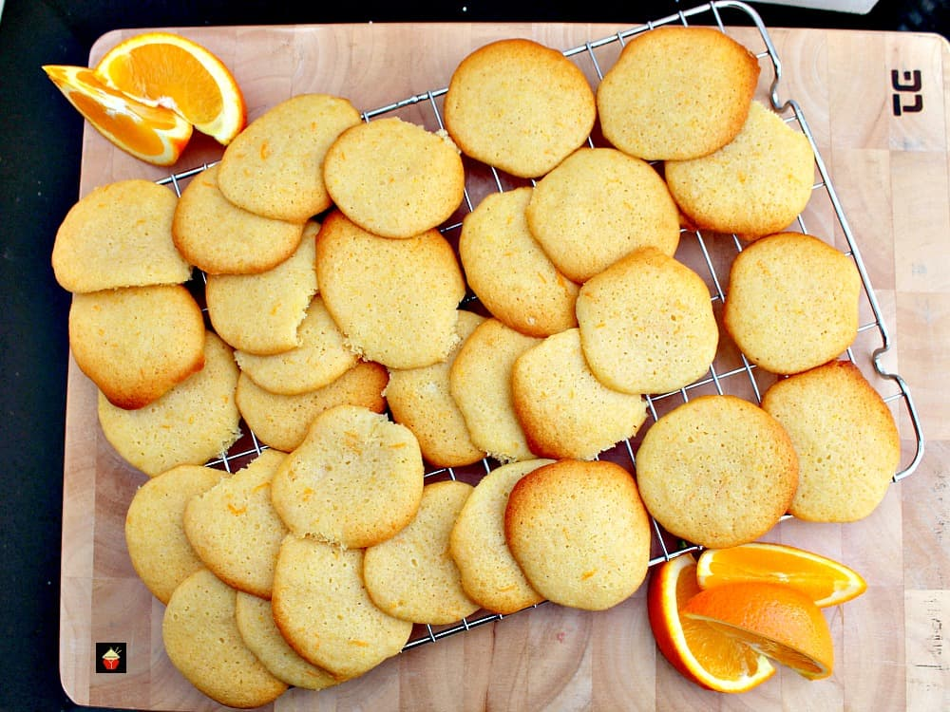
Grandma's War Time Orange Drop Cookies
Prep Time 15 minutes

Cook Time 10 minutes
Total Time 25 minutes

Ingredients
2 Tbs Orange Rind, grated
1/2 tsp Orange Flavouring
Juice of half an Orange
2/3 cup or 170 g Butter, softened
1 1/4 cups or 425 g Honey
1 Egg, beaten
2 1/2 cups or 310 g All Purpose Flour, sifted
3 Teaspoons Baking Powder
1/4 Teaspoon Salt

Instructions
- Preheat oven to 350 F or 180 C.
- Mix together the butter and honey.
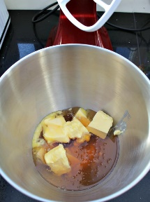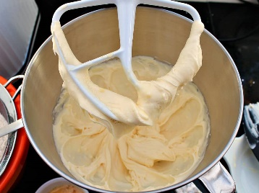
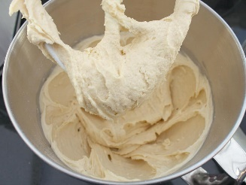
- Sift the flour, baking powder, and salt, then add to the honey mixture and fold in beaten eggs, grated orange rind and orange juice.
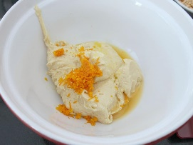

- Place in refrigerator for 30 minutes.
- Drop the batter in teaspoonfuls and bake for about 8 - 10 minutes.
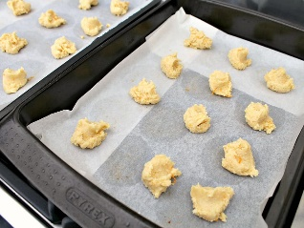
- When done, leave in baking tray for 5 minutes then place on a cooling rack until cool. Enjoy with a nice cold glass of milk!

